Program design
Student’s Name
Institutional Affiliation
Date

Assignment 1
Summary
The selected risk management plan is fall prevention and reduction program that targets the geriatric population in the community. The program recognizes individuals vulnerable to falls in the community and implements appropriate procedures for addressing their problems. The program seeks to provide an evidence-based practice intervention to help mitigate the risks of falls among the geriatric population. The project will operate under the name Louisiana Care Geriatrics (LCG).
The agency's mission is "protecting the welfare of the geriatric population by giving them confidence in walking." This agency has been on this mission for the last five years. The agency recognizes the geriatric population as the most vulnerable to falling.
Problem statement
Falling is a problem that affects many people aged 65 years and above. It is estimated that more than one in three people aged 65 years or older fall each year (Florence et al., 2018). 24% of those who fall sustain severe injuries, and 6% are fractured. The risk of falling and fall-related problems increase with an increase in age (Lee et al., 2013). As people age, the fear of falling intensifies even with people who have not fallen. This fear makes older people avoid activities like shopping, walking, or taking part in social activities. The most disturbing thing about falling is that it puts older adults at risk of serious injury. Falls can also lead to psychological, medical, physical, and economic consequences among the elderly (Lee et al., 2013). Falls among the elderly are an ever-increasing problem in both developing and developed countries. Though falls are a natural phenomenon in all humans, age-related falls are a big concern among the geriatric population. Falls among the geriatric population is both public health and community problem that needs to be addressed. Falls among the elderly have adverse effects such as disability and deformity, living in fear of falling, admission to a nursing home, poorer quality of life, curtailment of routine social activities, and direct medical care costs associated with injuries (Vellas et al., 1997). To address the problem of falls among the geriatric population, it is crucial to know the causes of falls. Most of the causes of falls among the elderly are caused by personal risk factors such as muscle weakness, problems with balance and gait, postural hypertension, visual impairment, and unsafe footwear. Some falls are also associated with confusion and side effects of a particular medication that causes dizziness. As people grow older, their joints become stifled, have decreased muscle strength, and impaired neurologic feedback. All these factors are a recipe for high falls among the elderly. The most prevalent risk factor to falling is previous falls, i.e., a person who has fallen before is more likely to fall again than a person who has not experienced falling before (Vellas et al., 1997).
Statistics show that falling among the elderly is a global problem. For example, in the United States, it is estimated that 30% of people aged 65 and above fall each year. It is also estimated that 30% of the elderly living in the community fall at least once every year in Australia. Similarly, in Canada, a third to half of the persons aged 65 and above are prone to falling, and the risk of falling increases with age. It is also estimated that the US healthcare system spent more than $19 billion in fall-related costs in 2000. The cost is projected to increase to $54.9 billion by 2020.
These figures give the grim statistics of the devastating effects falls have on the elderly population. The problem of falling places a considerable burden not only on the family members but also on society and the nation. The health care system is also stretched in caring for these people. The government spends a lot of money on the elderly population. It is therefore imperative for this problem to be addressed. With the prevention of each fall, the patient, family members, the healthcare system, and the government all benefit. This is why our agency is committed to preventing falls among the elderly in society.
Assignment two: objectives/Goals
The problem of falling among the geriatric population can be addressed in various dimensions. It is a problem that requires several approaches to deal with it. From ensuring the elderly have good health to having them have appropriate footwear, several approaches need to be assessed so that the elderly can live a comfortable life. In assignment one, the causes of falls among the elderly were identified. Three approaches are the best to deal with the said problem. One of them is ensuring that the elderly have the appropriate footwear that lowers the risk of falling. Secondly, ensuring the elderly have a balanced diet keeps them strong and avoids muscle weakness. Thirdly, is by eliminating the problem with balance and gait. These are the goals of this proposal.
Appropriate footwear
Appropriate footwear has been identified as one of the measures that can be taken to reduce falls among the elderly. Older people even opt to walk barefoot to avoid falling, especially when they are indoors (Koepsell et al., 2004). However, walking barefoot or in socks has been shown to increase the risk of falling. Other shoes that increase the risk of falls among the geriatric population are high heels and heavy shoes (Kelsey et al., 2010). Shoes with a stiff sole, heel collar height also increases the risk of falls among the elderly (Kelsey et al., 2010). Research shows that many older people should wear suboptimal shoes with low heels and firm-slip resistant soles to reduce the risk of falls. It is, therefore, imperative to maximize safe shoe use to offer an effective fall prevention strategy. Providing the elderly with safe walking shoes inside and outside of their home is one of its primary goals. The program aims at providing these older people with low-heeled shoes, light shoes, and shoes with firm slip-resistant soles to reduce the risk of falls among the elderly. Many older adults cannot afford these shoes because they are expensive, and they end up wearing any shoe that they can afford, which increases their risk of falling. The program aims to identify all people aged 65 years and above in California and provide them with the appropriate footwear. Footwear influences balance among the elderly and the subsequent risk of trips, slips, and falls. When one is wearing the appropriate shoe, the risk of falling decreases tremendously (Stevens et al., 2006).
Most falls among the elderly have been identified to occur during motor tasks. Footwear is a contributing factor for both indoor and outdoor falls. Research has established that walking barefoot, wearing socks without shoes, and wearing slippers increases the risk of falling among the elderly. The elderly will therefore be encouraged always to keep wearing well-fitting, non-skid rubber-soled, and low-heeled shoes and avoid walking barefoot.
Apart from footwear, our program intends to have visual aids for the elderly to help reduce falls among them. Poor vision is associated with falls in the geriatric population. As one grows older, the ability to see clearly reduces significantly. Most of the people above 65 years have problems with their eyes. This increases their chances of falling due to poor vision. Poor vision impairs balance and increases the risk of falls among the elderly. It is estimated that 1 in 11 people aged 65 and above is affected by vision problems (Stevens, 2005). This problem doubles their risk of falling. Many older people have opted to use multifocal glasses to aid their vision. However, they don't know that these glasses are not helpful and add to the risk of falling by impairing contrast sensitivity, thus increasing the risk of falls. Upon this realization, our program will roll out the exercise of educating older people on the importance of avoiding glasses to aid their vision. They should have regular eye care and checkup. Free treatment of glaucoma, a common cause of vision loss in older people, will be provided for the geriatric population.
Balanced diet
The health of the elderly deteriorates gradually, which makes them vulnerable to diseases. Apart from diseases, older adults have weak muscles that put them at the risk of falling and fracturing (Lohman et al., 2019). Osteoporosis is another problem prevalent among the geriatric population. Taking a balanced diet can help keep the bones strong and avoid falling. Although having healthy bones doesn't necessarily prevent falling, it prevents fractures when one falls. This may avert problems like disability, hospitalization, or even death. When people have strong bonds, the burden on the health care system is not stretched. Thus, the program will encourage the elderly to get enough calcium and vitamin D to keep their bones strong.
Project description
The name of the project is Louisiana Care Geriatrics (LCG). The purpose of the project is to reduce falls among the geriatric population. The project will be based in Baton Rouge, Louisiana. The program seeks to provide an evidence-based practice intervention to help mitigate the risks of falls among the geriatric population. The program recognizes falling among the elderly to be a problem that degrades these older people's lives. The geriatric population also deserves a better life like other people. The elderly will be identified by getting data from the United States Census Bureau, which is the body that conducts the population and housing census.
After the elderly (in this case, people who are 65 years and above) are identified, their personal details will be recorded. The details include age, sex, health status, and economic status. After that, these people will be provided with their appropriate footwear to minimize falls. Again, they will undergo teaching and sensitization against walking barefooted or using glasses unless advised by the doctor. Their close family friends will also be welcomed so that they help them observe the said protocols. Alongside the shoes, the elderly will be entitled to 3 liters of milk every day and $200 every week. The $200 is for buying other essentials like food so that they have a balanced diet.

Assignment 3: Logic model
Inputs  (Resources) | Processes  (activities) | Short- term Outcomes | Long-term outcomes | Impact
- Finances (money)  - Time  - Employees (staff) or volunteers  - Appropriate footwear  - Milk  - Partners  - Equipment | - Training of the elderly and their caregivers  - Training for mentors in the delivery of health messages.  - Providing milk to the elderly  - Ensuring the elderly eat balanced diets | - Reduced falls among the geriatric population.  - Fewer fractures in case fall happen.  - The elderly always wear shoes and do not walk barefooted. | - Better and more comfortable lives for the geriatric population  - The geriatric population walks comfortably with minimal falls.  - Reduced hospitalizations among the elderly. | - Reduced federal and state spending on the geriatric population  - Improved knowledge and action related to falls prevention among the elderly.  - The elderly community feels cared about and leads better lives.

The program's logic model consists of inputs, processes, outputs, short- and long-term outcomes, and impact. Inputs are the resources that will be used in the program. In our program, inputs will include money, time, employees, milk, partners, and equipment. Money will be required for the program's general implementation, such as paying the employees and mentors. Of course, there will be a need to create time for all the processes. Employees will be required to identify the elderly in Baton Rouge. We will also partner with volunteers who want to work with us in ensuring that the elderly lead a dignified life. The elders will need appropriate footwear to minimize falls and milk for strengthening their bones to avoid fractures when they fall.
Activities are processes what the program will do with the inputs to achieve its mission. Some of the activities in this program will include training the elderly on the importance of wearing shoes and avoiding walking barefooted, training the caregivers to handle the elderly, and providing milk to the elderly community. The short-term impacts include reduced falls among the elderly and fewer fractures in case of falls. The long-term outcomes are better living conditions for the elderly and fewer hospitalizations for the said population. It is expected that after the program is implemented, the number of older people being admitted to hospitals for fractures as a result of falls will reduce drastically. The impact of the program will be reduced federal and state spending on the healthcare of the elderly.
Assignment 4: flow chart
The principal top executive officials will be a project manager and a functional manager. To promote diversity and inclusion, the two officials will be of a different gender. The project will be headed by the project manager, who will be the program's chief executive officer. The manager will be responsible for hiring and firing other junior officials. There will also be the functional manager who will ensure that the project manager has all the resources for implementing the project. The functional manager will be responsible for collecting budget and cost estimates from project managers. He/she will also come up with a strategy for completing the given task. For example, he/she will determine where the training sessions will be held, how the elderly will be identified in the community, and how the milk will be procured and given to the identified persons. He/she will also provide training opportunities for employees and make general executive decisions for the program. The other important person will be a data analyst responsible for calculating each item's cost and projecting future budgets. An internal and external auditor will act as whistleblowers to prevent embezzlement of funds and for accountability purposes.
There will be a human resource management office headed by a human resource manager who will be responsible for looking at the employees' welfare. The HR manager will also be responsible for hiring new staff and solving any disputes arising from the employees. Hiring will be based on academic qualification. The program will ensure free and transparent hiring of employees. All The employees will consist of geriatric social workers. These people will be tasked with taking care of the geriatric community if the older adult does not have family support to take care of them. If the older person has a caring family, the social workers will work closely with the family members to ensure that they are well cared for. They can do so by close collaboration with the family members or conducting routine checkups for the assigned person (s). The social workers will also ensure that the assigned person has the recommended nutrition and other directives. In the spirit of promoting equality and inclusivity, the geriatric social workers will be males and females, including people of color.
Our program will partner with the state government in ensuring the elderly get a quality life in their latter years. We will also partner with the federal government for the same purpose. Volunteers will be welcomed to do the social work together with the geriatric social workers. We will also partner with all hospitals and healthcare centers in Louisiana to trace our track record (knowing how many people have been admitted for falls, what caused the falls etc.).
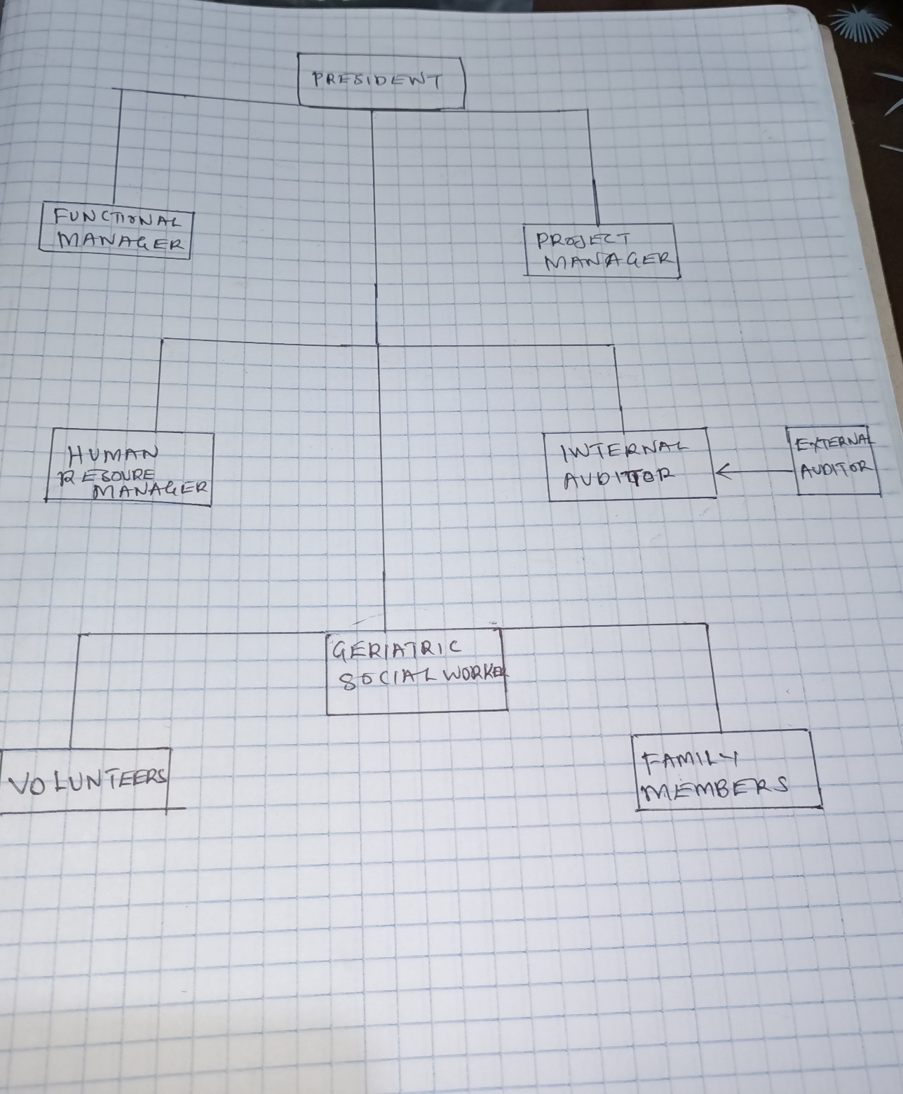
Assignment 5: Project evaluation
The effectiveness of the program will be determined in terms of cost efficiency and outcome. To know the success of the project, various evaluation techniques will be employed. Whether it is a success, the number of reported falls among the elderly must decrease within the first five years after the program's inception. Data will be obtained from hospitals in Louisiana. It is projected that, at the end of the first year, the elderly people who are admitted to hospitals for fractures or minor injuries will have reduced by at least 20%, with the falls reducing in the subsequent years. The previous year's data will be compared to the data for the year in which the program will be incepted. The reported falls for people aged 65 years and above will be compared with the statistics after the program has been enrolled. If the falls have reduced after five years of enrollment in the program, the program will be a success. However, if the numbers remain the same or worsen, the program will be deemed to be unsuccessful.
Another method of evaluating the project's success is by comparing the healthcare system's cost for the previous years and the current year (when the program is enrolled). The cost used to treat elderly people from fractures and injuries will be expected to reduce by half. One of the effects of falls among the elderly is that they are costly to the government. The federal government spends a lot of money on fall-related costs among the elderly. It is estimated that about $50 billion is spent on medical costs to nonfatal fall injuries, and $754 million is spent on related to fatal falls (Haddad et al., 2019). The cost of nonfatal falls is mainly taken care of by Medicare ($29 billion) and Medicaid ($9 billion). The costs are calculated in terms of hospital and nursing home care fees, doctors and other professional services, medical equipment, prescription drugs, community-based services, rehabilitation, and insurance processing. Direct costs such as reduced quality of life and dependence are excluded. In Louisiana, the average cost for a hospital stay due to unintentional fall injury among the elderly was around $38,000 in 2018. Women were 1.5 times as likely to be hospitalized for hip fractures than men in the same age group. For the program to be deemed successful, these costs must reduce drastically after three years of the program's activity.
Assignment 6: Budget
Like any other program, this project will require money for it to be fully implemented. Cash will be used in various departments.
Personnel number cost
Project manager 1 1200
Functional manager
Research experts 5 800
data analysts 2 1000
Trainers (geriatric social workers) 30 500
Volunteers ---- ----
Equipment
Training materials
Transport
Refreshments
Computers
Mobile phone
Elderly requirements
Foodstuff
Milk
Other foods
Appropriate footwear
Milk

Our budget ranges from personnel to equipment required in the project. A team of experts will determine the exact cost of all the items. We will hire accountants who will calculate the exact cost of each item. However, we expect much of the cost to purchase the footwear, provide milk, and train the caregivers.

References
Florence, C. S., Bergen, G., Atherly, A., Burns, E., Stevens, J., & Drake, C. (2018). Medical costs of fatal and nonfatal falls in older adults. Journal of the American Geriatrics Society, 66(4), 693-698.
Haddad, Y. K., Bergen, G., & Florence, C. (2019). Estimating the economic burden related to older adult falls by state—Journal of public health management and practice: JPHMP, 25(2), E17.
Kelsey, J. L., Procter-Gray, E., Nguyen, U. S. D., Li, W., Kiel, D. P., & Hannan, M. T. (2010). Footwear and falls in the home among older individuals in the MOBILIZE Boston study. Footwear Science, 2(3), 123-129.
Koepsell, T. D., Wolf, M. E., Buchner, D. M., Kukull, W. A., LaCroix, A. Z., Tencer, A. F., ... & Larson, E. B. (2004). Footwear style and risk of falls in older adults. Journal of the American geriatrics society, 52(9), 1495-1501.
Lee, A., Lee, K. W., & Khang, P. (2013). Preventing falls in the geriatric population. The Permanente Journal, 17(4), 37.
Lohman, M. C., Sonnega, A. J., Nicklett, E. J., Estenson, L., & Leggett, A. N. (2019). Comparing estimates of fall-related mortality incidence among older adults in the United States. The Journals of Gerontology: Series A, 74(9), 1468-1474.
Stevens, J. A. (2005). Falls among older adults—risk factors and prevention strategies. Journal of safety research, 36(4), 409-411.
Stevens, J. A., Corso, P. S., Finkelstein, E. A., & Miller, T. R. (2006). The costs of fatal and nonfatal fall among older adults. Injury prevention, 12(5), 290-295.
Vellas, B. J., Wayne, S. J., Romero, L. J., Baumgartner, R. N., & Garry, P. J. (1997). Fear of falling and restriction of mobility in elderly fallers. Age and aging, 26(3), 189-193.

